📊 Using Rubrics in D2L Brightspace
Attach rubrics to assignments and discussions for fast, consistent grading.

📌 Why Use Rubrics?
✅ Ensures Consistent Grading – Eliminates subjectivity by defining clear expectations.
✅ Saves Time – Click-to-score method speeds up assessment.
✅ Provides Detailed Feedback – Students can see exactly where they lost or gained points.
✅ Works with Assignments, Discussions, and Grade Items – Can be attached to multiple assessment types.

🛠 How to Create & Attach a Rubric in D2L Brightspace

Create a Rubric
- Go to Edit Course → Select Rubrics or click Rubrics under the Course Tools navbar.
- Click “New Rubric”
  - Set a Name (e.g., "Discussion Participation" or "Essay Grading").
  - Choose a Scoring Method:
    - Analytic (Multiple criteria, weighted scores).
    - Holistic (Single overall score).
- Define Criteria & Levels
  - Example: Poor, Fair, Good, Excellent (or custom levels).
  - Assign point values to each level.
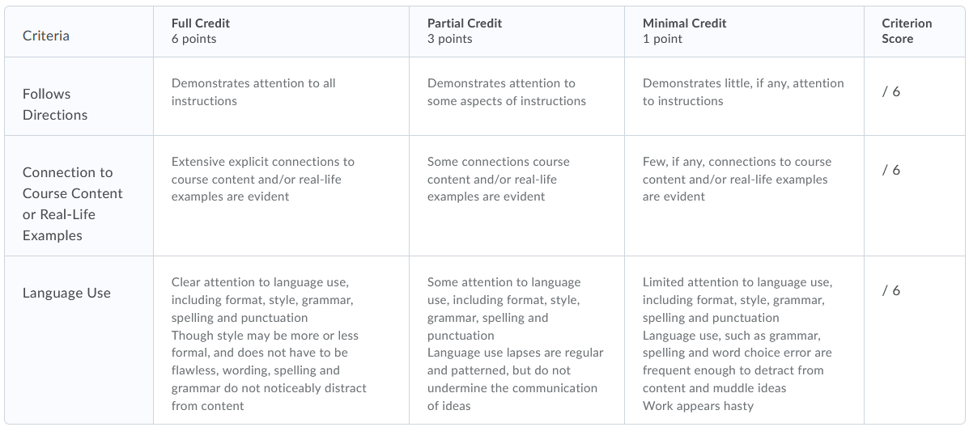
- Change Status: automatically it will be set to Publish when you close it, but you have the option to set it to Draft if you are still actively making changes.
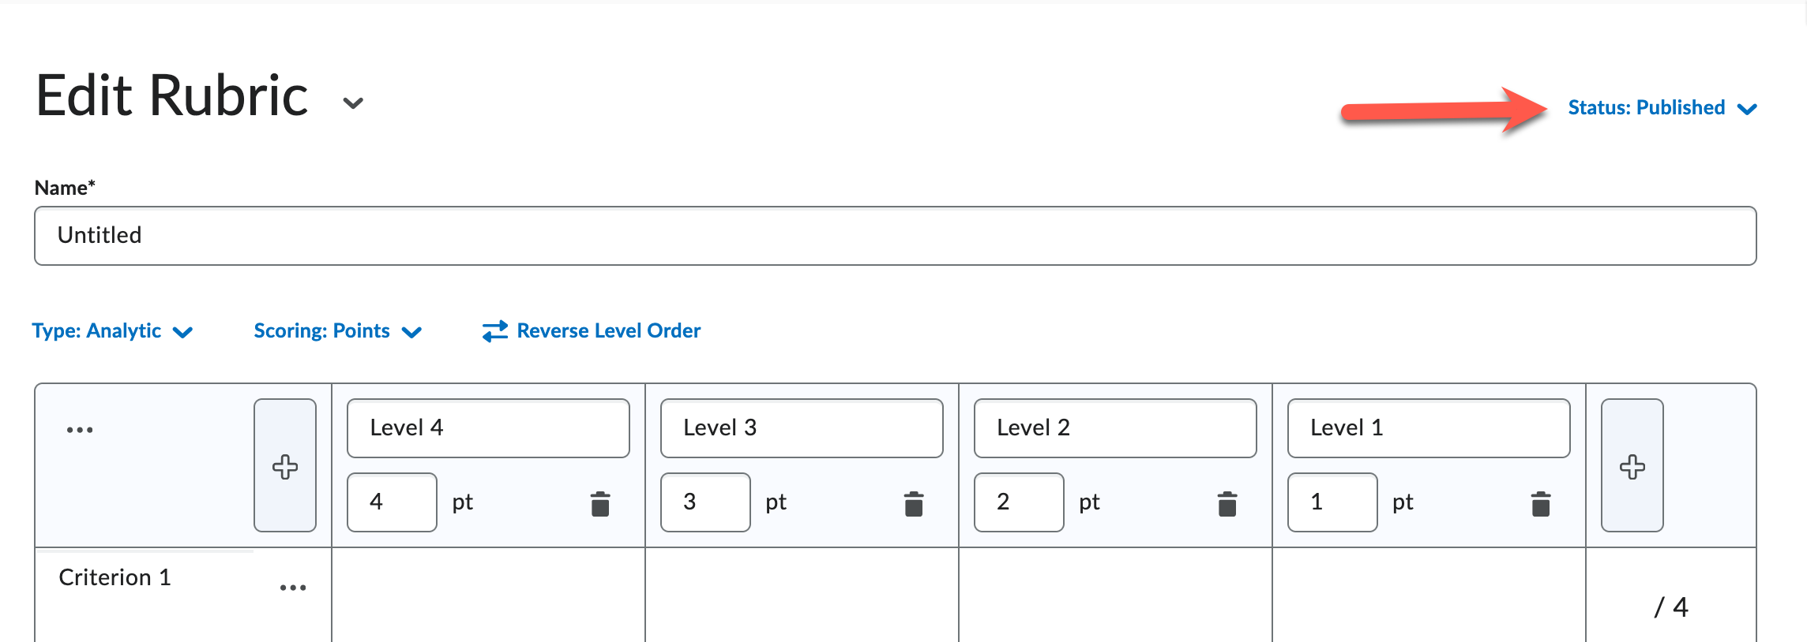
- Close
Attach a Rubric to Assignments or Discussions
📑 For Assignments
- Under the Activities navbar, select “Assignment Dropboxes” → Select or create an assignment.
- Scroll to the Evaluation & Feedback section.
- Click “Add Rubric” → Choose an existing rubric or create a new one.
- Save & Close.
💬 For Discussions
- Under the Activities navbar, select “Discussions” → Select or create a discussion topic.
- Expand the “Evaluation & Feedback” section.
- Under “Rubrics” → Click “Add Rubric” and select your rubric.
- Save & Close.

Enable Inline Rubric Feedback for Clarity
✏ How to Allow Students to See Rubric Feedback Directly on Their Submissions
- While grading, you will see the Rubrics”.
- Select performance levels by clicking rubric criteria.
- Add comments in each rubric section (optional).
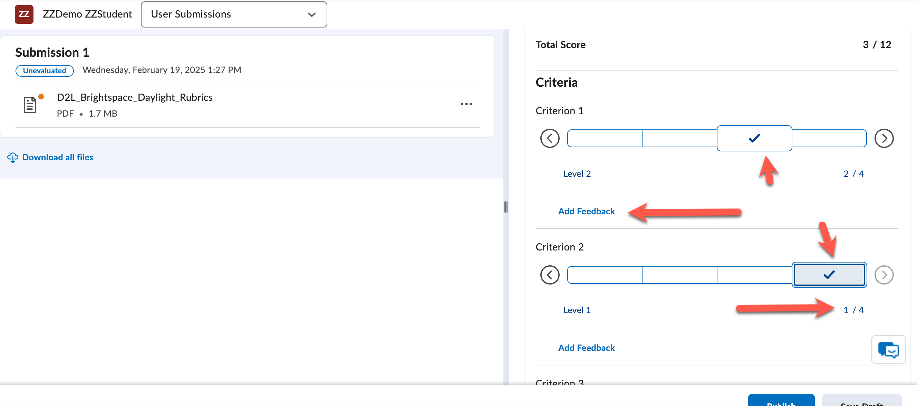
- Ensure “Make Rubric Visible to Students” is checked.
- Save & Publish for student access.

💡 Additional Tips & Best Practices
✅ Use Prebuilt Rubric Templates – Save time by duplicating and modifying rubrics.
✅ Make Rubrics Visible Before Submission – Helps students understand expectations.
✅ Check Student View – Ensure the rubric displays correctly in the grading interface.

